



Haiti, One Year After the Earthquake
Perspectives on international humanitarian response to natural disasters
and on the role of governance in reconstruction and development

Wednesday 23 February 2011
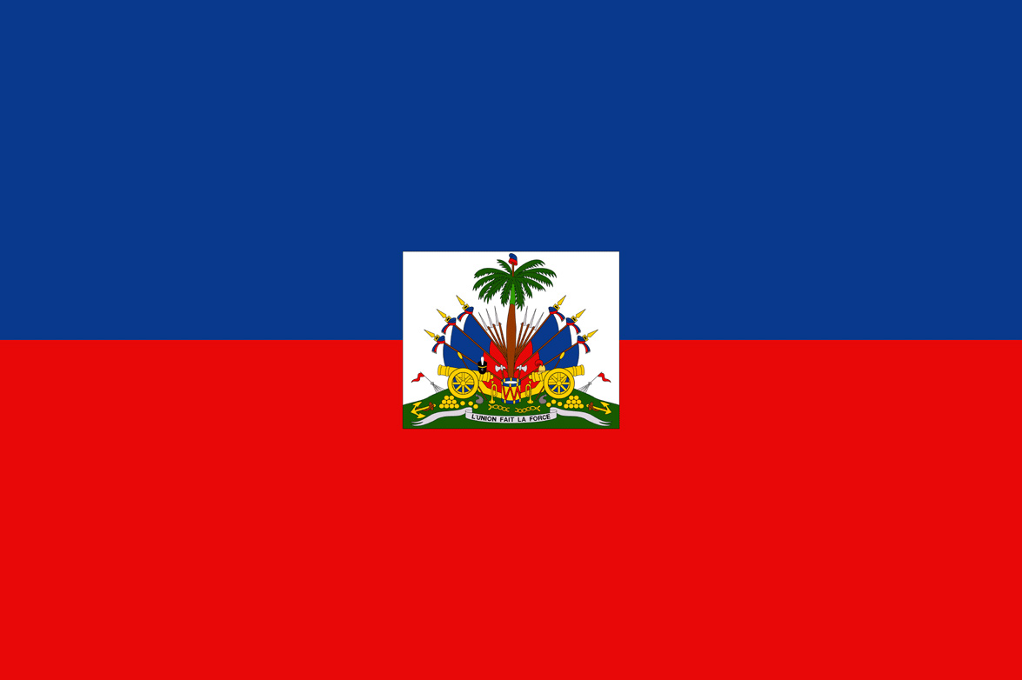
Palais d’Egmont, Place du Petit Sablon 8 bis, 1000 Brussels

- PROGRAMME -

08.30 Registration and Welcome Coffee

09.00 Opening Remarks
Master of Ceremonies: Jacki Davis
Etienne Davignon, Chairman of Egmont
Raymond Magloire, Ambassador of Haiti to the EU & Belgium
Ross Hornby, Ambassador of Canada to the EU

09.15 Opening Keynote Address
Lawrence Cannon, Minister of Foreign Affairs of Canada

09.35 Panel Debate I: “HUMANITARIAN RESPONSE TO NATURAL DISASTERS”
- Reflections on international & European humanitarian aid coordination in response to natural disasters, with Haiti as a case study
- The use of civil protection assets & rapid reaction mechanisms in disaster response
- The role of the military in humanitarian situations
- Working with domestic NGOs and building local capacity
Panel moderator: Jacki Davis
09.35 Introduction:
- Michael Bonser, Director, Humanitarian Affairs & Disaster Response Division, Foreign Affairs and International Trade Canada (DFAIT) (tbc)
- Peter Zangl, Director General, European Commission Humanitarian Office (ECHO)
09.55 Panel discussion:
- Marie Alta Jean-Baptiste, Head of Civil Protection, Government of Haiti (tbc)
- Nancy Lindborg, Assistant Administrator, Bureau for Democracy, Conflict and Humanitarian Assistance, US Agency for International Development (USAID)
- Rashid Khalikov, Director of Operations, UN Office for the Coordination of Humanitarian Affairs (OCHA)
- Nigel Fisher, Deputy Special Representative of the Secretary-General and UN Resident Coordinator and Humanitarian Coordinator in Haiti, MINUSTAH
- Christopher Stoke, Director General (Belgium), Médecins Sans Frontières (MSF)

11.30 Coffee break

11.45 Introduction of speakers
Louis de Lorimier, Ambassador of Canada to Belgium & Luxembourg

11.50 Keynote Address
Steven Vanackere, Belgian Deputy Prime Minister and Minister of Foreign Affairs and Institutional Reform

12.10 Keynote Address
Michaëlle Jean, UNESCO Special Envoy for Haiti

12.30 Lunch and Photo Exhibition

13.45 Panel Debate II: “THE ROLE OF GOVERNANCE IN HAITI’S RECONSTRUCTION & DEVELOPMENT”
- Haiti as a case study
- Governance as a key ingredient to Haiti’s long-term reconstruction and development
- The role of civil society and the Haitian diaspora
Panel moderator: Jacki Davis
13.45 Introduction:
- Christian Leffler, Managing Director (Americas), European External Action Service (EEAS)
- Denis Robert, Director, Haiti Task Force, Foreign Affairs & International Trade Canada (DFAIT)
14.05 Panel discussion:
- Haitian representative (tbc)
- Gary Quince, Director, ACP Geographical Coordination and Supervision, EuropeAid Development and Cooperation (DEVCO), European Commission
- Thomas Adams, US Special Coordinator for Haiti (tbc)
- Pierre Duquesne, French Ambassador for Haiti Reconstruction
- Bernice Robertson, Haiti Senior Analyst, International Crisis Group
- Pierre Esperance, Director, National Human Rights Defence Network, Haiti
- Daniel Holly, Professor, Political Science Department, Université du Québec à Montréal

16.00 Coffee break

16.20 Joint Keynote Address: “REINFORCING THE LINK FROM RELIEF TO REHABILITATION TO LONG-TERM DEVELOPMENT”
Andris Piebalgs, European Commissioner for Development
Kristalina Georgieva, European Commissioner for International Cooperation, Humanitarian Aid & Crisis Response

16.45 Closing Keynote Address: “HAITI AS AN EXTERNAL RELATIONS PRIORITY FOR THE EUROPEAN UNION”
Catherine Ashton, High Representative of the Union for Foreign Affairs and Security Policy and Vice-President of the European Commission

  - Conclusions and Wrap-Up

17.30 Reception
Featuring music by Haitian-Canadian artist ‘Spaïcy’ and Haiti photo exhibition. Hosted by:
- Ross Hornby, Ambassador of Canada to the EU
- Louis de Lorimier, Ambassador of Canada to Belgium & Luxembourg
- Raymond Magloire, Ambassador of Haiti to the EU & Belgium

